**DAILY ONLINE ACTIVITIES SUMMARY**

|  |  |  |  |  |  |  |  |  |
| --- | --- | --- | --- | --- | --- | --- | --- | --- |
| **Date:** | **30-07-2020** | | | | | **Name:** | **NAIPUNYA VINOD NAIK** | |
| **Sem & Sec** | **IV SEM & A SECTION** | | | | | **USN:** | **4AL18CS050** | |
| **Online Test Summary** | | | | | | | | |
| **Subject** | | **MICROCONTROLLER AND EMBEDDED SYSTEMS** | | | | | | |
| **Max. Marks** | | **30** | | **Score** | | | **N/A** | |
| **Certification Course Summary** | | | | | | | | |
| **Course** | **1)** EXCEL FOR BEGINNERS:FUNCTIONS, FORMULAS, SHORTCUTS & MORE  **2)** UNITY GAME DEVELOPERS FOR BEGINNERS | | | | | | | |
| **Certificate Provider** | | | **1) UDEMY**  **2) UDEMY** | | **Duration** | | | **1) 1.5 HRS**  **2) 1 HR** |
| **Coding Challenges** | | | | | | | | |
| **Problem Statement: NO PROBLEM STATEMENT GIVEN TODAY** | | | | | | | | |
| **Status:------------------------** | | | | | | | | |
| **Uploaded the report in Github** | | | | | **YES** | | | |
| **If yes Repository name** | | | | | <https://github.com/naipunya-naik/daily-progress-report> | | | |
| **Uploaded the report in slack** | | | | | **YES** | | | |

Online Test Details: (Attach the snapshot and briefly write the report for the same).

TODAY MICROCONTROLLER AND EMBEDDED SYSTEMS I.A DESCRIPTIVE TEST-2 WAS CONDUCTED ON 30TH JULY 2020.

* SUBJECT:- MICROCONTROLLER AND EMBEDDED SYSTEMS
* CONDUCTED BY:- MR.VASUDEV S SHAHAPUR
* FROM 9.30 AM TO 10:30AM
* DURATION:- 1 HR
* NO.OF QUESTIONS:- 4
* TOTAL MARKS:- 30
* MARKS WILL BE PROVIDED SOON
* 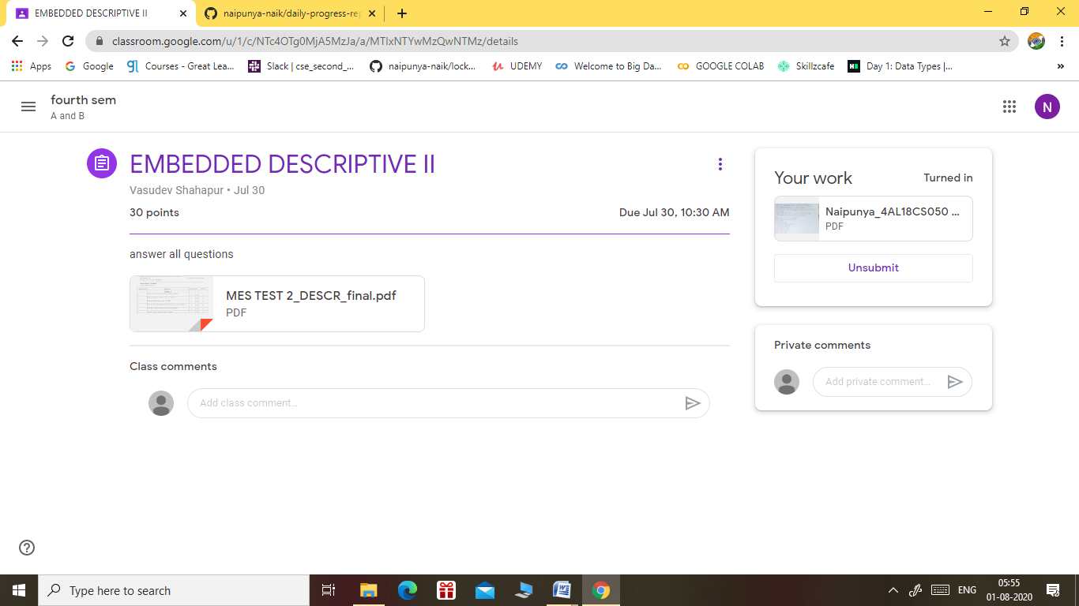

Certification Course Details: (Attach the snapshot and briefly write the report for the same).

CERTIFICATION COURSE NAME:- EXCEL FOR BEGINNERS:FUNCTIONS, FORMULAS, SHORTCUTS & MORE



CERTIFICATION COURSE NAME:- UNITY GAME DEVELOPERS FOR BEGINNERS

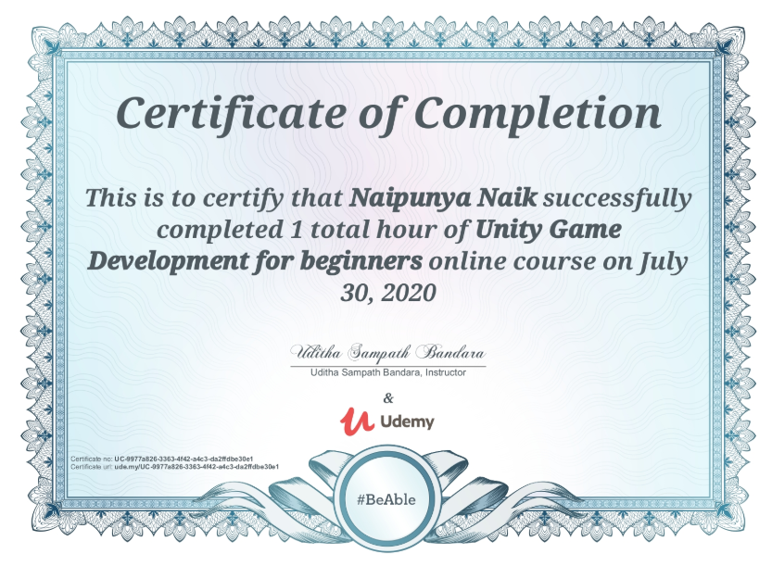

Coding Challenges Details: (Attach the snapshot and briefly write the report for the same).

NO PROBLEM STATEMENT GIVEN TODAY